**The first fully annotated chloroplast sequence of the large pantropical family Annonaceae.**

Authors: Rita D. Brandão1,*, Martijn Staats2, Lars W. Chatrou2, Jan W. Maas3, Hans Persoon4, Tatiana Arias5, Roy H.J. Erkens1,6

1. Maastricht Science Programme, Maastricht University, PO Box 616, 6200 MD Maastricht, The Netherlands
2. Biosystematics group, Wageningen University, Wageningen, The Netherlands
3. Ecology and Biodiversity Group, Department of Biology, Utrecht University, Utrecht, The Netherlands
4. Botanical Garden Utrecht, Utrecht University, Utrecht, The Netherlands
5. School of Biological Sciences, The University of Hong Kong, China
6. Naturalis Biodiversity Center, Leiden, The Netherlands

**Abstract**

**Introduction**

Understanding the origin of flowering-plant biodiversity is one of the major biological research themes of the moment. A lot of effort has been devoted to studying the monocot and eudicot lineages but less to the other large clade of flowering plants, Magnoliidae, although it contains c. 4% of all plant species. Within Magnoliidae, the pantropically distributed Annonaceae is by far the most genus-rich family, with 108 genera and *c*. 2,400 species1,2, and the third richest in

terms of species behind Piperaceae (five genera, *c*. 3,100 species) and Lauraceae (50 genera, *c*. 2,500 species) 3. Understanding the evolution and diversification of Annonaceae will therefore greatly aid in understanding the evolution of basal angiosperms. However, also the evolution of tropical rainforests will be better understood given the fact that, in terms of species richness and abundance of individuals, Annonaceae contributes significantly to tropical rainforest diversity4-6.

Molecular phylogenetic studies in Annonaceae, as in many others, have been conducted using a few chloroplast markers whether it be at the family, subfamily or tribal7-9, or generic levels10-12. The suit of plastid markers available is limited, mainly due to the fact that previous knowledge of the chloroplast DNA sequence is needed to develop them. Nowadays, it is possible to sequence entire plastomes of these plants (using methods such as published by for instance Staats et al. 201313) and use these larger amounts of data to identify more relevant regions for resolving phylogenies of difficult clades[14-17](#_ENREF_14" \o "Bortiri, 2008 #93). In fact, in the genome repository GenBank[18](#_ENREF_18" \o "Benson, 2013 #102) there are almost 650 plant chloroplast genome entries, of which around 500 are from flowering plants19. Despite the increasing number of chloroplast genomes every year, until this study, no chloroplast genome was available for Annonaceae. Here, we describe the first plastome of an Annonaceae tree: *Uvaria afzelii* (tribe Uvarieae, subfamily Annonoideae[12](#_ENREF_12" \o "Chatrou, 2012 #14)). *Uvaria afzelii* is a tree or spreading shrub growing up to 5 metres tall, distributed from Guinea to southern Nigeria; the fruit is edible and leaves, bark and roots are used for their medicinal properties20. Knowing the chloroplast genome of *Uvaria afzeili* will allow to reconstruct more easily chloroplast genomes from other Annonaceae species, or to make baits for targeting enrichment sequencing approaches. This will in the end contribute to more data to facilitate molecular phylogenetic reconstructions of the family and therefore enabling improved analyses of Annonaceae itself and magnoliid evolution.

**Results and discussion**

In this study we report the first completely annotated chloroplast genome of a species of Annonaceae (*Uvaria afzelii)*. The results of the quality control program Fastq Screen show that only a small percentage of all the reads belong to the chloroplast sequence (figure 1). Less than 0.5% of the total number of reads was aligned to the unpublished draft plastome of *Miliusa cuneata*, which was used as a reference. The majority of the reads did not correspond to human, mouse or insect DNA, therefore are inferred to be nuclear and/or mitochondrial plant DNA. After assembly of the reads by mapping to the reference chloroplast followed by several iteration mapping steps, the percentage of used reads was 0.7%. The few gaps (parts with coverage below 2x) were identified and resolved using *in silico* primer walking and PCR followed by automated Sanger sequencing method.

**Figure 1. Percentage of mapped reads of *Uvaria afzelii* to different genomes.** Genome libraries used to map the raw reads were the following: *Homo sapiens*, *Mus musculus*, *Rattus norvegicus*, *Drosophila melanogaster*, *Anopheles gambiae*, and *Saccharomyces cerevisiae*. The chloroplast genome used was from *Miliusa cuneata*. No library refers to all reads that didn't map to any of the libraries used.

The complete chloroplast genome of *Uvaria afzelii* is around 167,530 bp and is shown in figure 2. It is noteworthy that small indels, as well as SNPs, were observed in heteroplasmy, so the actual genome size varies slightly from the given length. The inverted repeats (IRs) have 28,002 and 28.095 bp respectively and are separated by the small single-copy region (20,010 bp) and the long single-copy region (91,296 bp). We found 139 genes in the chloroplast DNA of *Uvaria afzelii*, 21 of which are completely duplicated and 2 partially duplicated within the IRs. The most noteworthy features of its chloroplast genome is an inversion within the LSC (57,722 - 66,951 bp) compared to the chloroplasts of *Magnolia kwansiensis*[21](#_ENREF_21" \o "Kuang, 2011 #19)and *Liriodendron tulipifera*[22](#_ENREF_22" \o "Cai, 2006 #18).

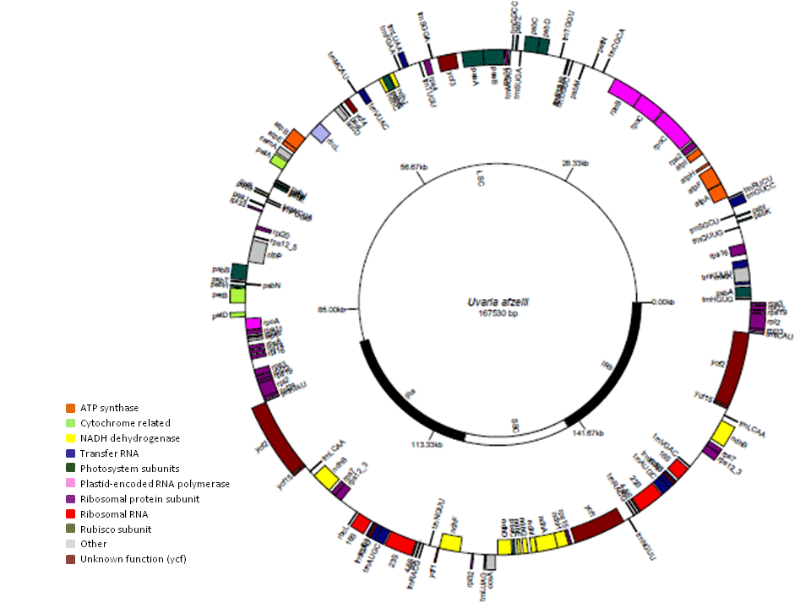

Uvaria afzelii 167,530 bp

**Figure 2. Plastome map of Uvaria afzelii.** Genes in the outer side of the circle have sense orientation genes, whereas the inner side shows anti-sense oriented genes. Genes have been coloured according to their function.

It is important to realise that despite the chloroplast representation in figure 2 showing a circular molecule and the fact that Genbank accessions mention that chloroplast genome is circular, the chloroplast DNA mostly has a complex and branched form, and the circular form is only present in small amounts23. Probably due to this particularity of the plastome molecule, PCRs over the IRb/LSC boundary, where the chloroplast should circularize, were not successful.

Chloroplast DNA is the most gene-rich molecule of the three genomes of a plant cell, with more than 100 genes, spanning over 100-200 kb, that code for the entire machinery necessary for the photosynthetic process. There is a relatively high degree of conservation in size, structure, gene content, and linear order of the chloroplast genes in land plants24. In chloroplasts, DNA replication is cell-cycle independent and the number of chloroplast copies present per cell varies. In rapidly dividing leaf tissue there are around hundred copies, but later in leaf development and plant growth, the number of copies decreases to about 20-3025. In addition, each chloroplast may contain up to 300 copies of the genome26. Despite the abundance of the chloroplast genome, genome skimming (shallow sequencing) experiments show that only a small percentage of the reads actually map to the chloroplast. So, targeting enrichment sequencing is a very promising technique to sequence the plastome from many different species. However, unlike the standard NGS sequencing protocols, this technique requires some *a priori* knowledge of the genome sequence, such as the genome of closely related species. The sequencing of Annonaceae chloroplasts, such as the one presented here will now allow for the construction of (home-made) chloroplast-target probes for the sequencing of many complete chloroplast genomes and will allow molecular phylogenetic reconstructions of Annonaceae and an improved understanding of magnoliid evolution.

**Materials and Methods**

Sample preparation

Fresh leaf material from *Uvaria afzelii* was collected from a green-house grown tree at the botanical garden of Utrecht University (Utrecht, The Netherlands). The chloroplast isolation kit (Sigma, Saint-Louis, USA) was used according to the manufacturer’s instructions. DNA extraction from the chloroplasts was performed with the GenElute plant genomic DNA miniprep kit (Sigma). The obtained DNA was sent to Macrogen (Korea) for paired-end library construction and sequencing on a HiSeq 2000 (Illumina) instrument, following the company’s protocol.

Sequencing analysis

Quality control was performed with FastQC and FastQ Screen (both available at http://www.bioinformatics.babraham.ac.uk/projects/download.html). Geneious version 6.0627 ([http://www.geneious.com](http://www.geneious.com/)) was used to filter poor quality bases and/or reads and iterative mapping steps. In the first mapping step, reads were mapped to the draft sequence of a chloroplast of *Miliusa cuneata*, an Asian Annonaceae species (kindly provided by Tatiana Arias, manuscript in preparation), to assemble a draft of the *U. afzelii* plastome. In the following 20 steps, consecutive rounds of mapping to the obtained sequences were performed. Remaining gaps were resolved in two ways: a) *in silico* primer walking using the *de novo* assembler PRICE28 on previously filtered data from the software TrimGalore! (available at http://www.bioinformatics.babraham.ac.uk/projects/download.html); b) PCRs using primers flanking the gaps followed by automated Sanger sequencing.

Gene annotation and chloroplast circular map design

Gene annotation was performed in Geneious software upon alignment of the complete chloroplast sequences of *Liriodendron tulipifera*[22](#_ENREF_22" \o "Cai, 2006 #18) (genbank accession number: NC_008326.1) and *Magnolia kwangsiensis*[21](#_ENREF_21" \o "Kuang, 2011 #19) (genbank accession number: NC_015892.1) using the MAFF package, and in DOGMA29. The exact boundaries between the inverted repeats and the single copies were determined manually. GenomeVx30 was used to draw the circular map of the chloroplast genome.

**References**

1 Massoni, J., Couvreur, T. L. & Sauquet, H. Five major shifts of diversification through the long evolutionary history of Magnoliidae (angiosperms). *BMC Evolutionary Biology* **15**, 49 (2015).

2 Couvreur, T. L. P. et al. Early evolutionary history of the flowering plant family Annonaceae: steady diversification and boreotropical geodispersal. *Journal of Biogeography* **38**, 664-680 (2011).

3 Erkens, R. H. J., Chatrou, L. W. & Couvreur, T. L. P. Radiations and key innovations in an early branching angiosperm lineage (Annonaceae; Magnoliales). *Botanical Journal of the Linnean Society* **169**, 117-134 (2012).

4 van Gemerden, B. S., Olff, H., Parren, M. P. E. & Bongers, F. The pristine rain forest? Remnants of historical human impacts on current tree species composition and diversity. *Journal of Biogeography* **30**, 1381-1390 (2003).

5 Gentry, A. H. Tree species richness of upper Amazonian forests. *Proceedings of the National Academy of Sciences* **85**, 156-159 (1988).

6 Valencia, R., Balslev, H. & Paz Y Miño C, G. High tree alpha-diversity in Amazonian Ecuador. *Biodivers Conserv* **3**, 21-28 (1994).

7 Pirie, M. D., Chatrou, L. W., Mols, J. B., Erkens, R. H. J. & Oosterhof, J. ‘Andean-centred’ genera in the short-branch clade of Annonaceae: testing biogeographical hypotheses using phylogeny reconstruction and molecular dating. *Journal of Biogeography* **33**, 31-46 (2006).

8 Erkens, R. H. J., Maas, J. W. & Couvreur, T. L. P. From Africa via Europe to South America: migrational route of a species-rich genus of Neotropical lowland rain forest trees (Guatteria, Annonaceae). *Journal of Biogeography* **36**, 2338-2352 (2009).

9 Chaowasku, T. et al. A plastid DNA phylogeny of tribe Miliuseae: Insights into relationships and character evolution in one of the most recalcitrant major clades of Annonaceae. *American Journal of Botany* **101**, 691-709 (2014).

10 Su, Y. & Saunders, R. Evolutionary divergence times in the Annonaceae: evidence of a late Miocene origin of Pseuduvaria in Sundaland with subsequent diversification in New Guinea. *BMC Evolutionary Biology* **9**, 153 (2009).

11 Erkens, R. H. J. et al. A decade of uncertainty: Resolving the phylogenetic position of Diclinanona (Annonaceae), including taxonomic notes and a key to the species. *Taxon* **63**, 1244–1252 (2014).

12 Chatrou, L. W. et al. A new subfamilial and tribal classification of the pantropical flowering plant family Annonaceae informed by molecular phylogenetics. *Botanical Journal of the Linnean Society* **169**, 5-40 (2012).

13 Staats, M. et al. Genomic treasure troves: complete genome sequencing of herbarium and insect museum specimens. *PLoS ONE* **8**, e69189 (2013).

14 Bortiri, E., Coleman-Derr, D., Lazo, G. R., Anderson, O. D. & Gu, Y. Q. The complete chloroplast genome sequence of Brachypodium distachyon: sequence comparison and phylogenetic analysis of eight grass plastomes. *BMC Research Notes* **1**, 61-61 (2008).

15 Huang, H., Shi, C., Liu, Y., Mao, S.-Y. & Gao, L.-Z. Thirteen Camellia chloroplast genome sequences determined by high-throughput sequencing: genome structure and phylogenetic relationships. *BMC Evolutionary Biology* **14**, 151 (2014).

16 Matsuoka, Y., Yamazaki, Y., Ogihara, Y. & Tsunewaki, K. Whole Chloroplast Genome Comparison of Rice, Maize, and Wheat: Implications for Chloroplast Gene Diversification and Phylogeny of Cereals. *Molecular Biology and Evolution* **19**, 2084-2091 (2002).

17 Shaw, J., Lickey, E. B., Schilling, E. E. & Small, R. L. Comparison of whole chloroplast genome sequences to choose noncoding regions for phylogenetic studies in angiosperms: the tortoise and the hare III. *American Journal of Botany* **94**, 275-288 (2007).

18 Benson, D. A. et al. GenBank. *Nucleic Acids Research* **41**, D36-D42 (2013).

19 Information, N. C. f. B. *GenBank*, <http://www.ncbi.nlm.nih.gov/genbank/> (

20 Burkill, H. M. *The useful plants of West Tropical Africa*. Vol. 1 (Royal Botanic Gardens, 1985).

21 Kuang, D.-Y. et al. Complete chloroplast genome sequence of Magnolia kwangsiensis (Magnoliaceae): implication for DNA barcoding and population genetics. *Genome* **54**, 663-673 (2011).

22 Cai, Z. et al. Complete plastid genome sequences of Drimys, Liriodendron, and Piper: implications for the phylogenetic relationships of magnoliids. *BMC Evolutionary Biology* **6**, 77 (2006).

23 Bendich, A. J. Circular Chloroplast Chromosomes: The Grand Illusion. *The Plant Cell Online* **16**, 1661-1666 (2004).

24 Downie, S. & Palmer, J. in *Molecular Systematics of Plants* (eds PamelaS Soltis, DouglasE Soltis, & JeffJ Doyle) Ch. 2, 14-35 (Springer US, 1992).

25 Possingham, J. V. Plastid replication and development in the life cycle of higher plants. *Annual Review of Plant Physiology* **31**, 113-129 (1980).

26 Krupinska, K., Melonek, J. & Krause, K. New insights into plastid nucleoid structure and functionality. *Planta* **237**, 653-664 (2013).

27 Kearse, M. et al. Geneious Basic: An integrated and extendable desktop software platform for the organization and analysis of sequence data. *Bioinformatics* **28**, 1647-1649 (2012).

28 Ruby, J. G., Bellare, P. & DeRisi, J. L. PRICE: Software for the Targeted Assembly of Components of (Meta) Genomic Sequence Data. *G3: Genes|Genomes|Genetics* **3**, 865-880 (2013).

29 Wyman, S. K., Jansen, R. K. & Boore, J. L. Automatic annotation of organellar genomes with DOGMA. *Bioinformatics* **20**, 3252-3255 (2004).

30 Conant, G. C. & Wolfe, K. H. GenomeVx: simple web-based creation of editable circular chromosome maps. *Bioinformatics* **24**, 861-862 (2008).